**CAPSTONE PROJECT**

We Brainstormed On Fast Food Industries And They Are:-

1-**McDonald’s** :- A global fast-food chain known for its hamburgers, fries, and iconic golden arches.

2-**Subway** :-A sandwich shop offering customizable subs, salads, and wraps, with a focus on fresh ingredients.

3-**Starbucks** :-A renowned coffeehouse chain recognized for its specialty coffee drinks, teas, and pastries.

4-**Burger King** :-A fast-food restaurant famous for flame-grilled burgers, Whoppers, and a diverse menu of quick bites.

5-**Pizza Hut** :-A pizza restaurant chain known for its pizzas, pasta dishes, and a variety of sides, often available for delivery or dine-in.

**Now, We Chose Subway For Detailed Description**:-

**SUBWAY**

**Problem statement:-**

We choosed subway because Regarding Subway, one problem with their brand in recent years has been related to inconsistency in their ingredient quality and freshness. Some customers have reported variations in the quality of ingredients from one location to another, which can affect the overall perception of the brand and its commitment to providing healthy options. This inconsistency can undermine trust and customer satisfaction.The subway food industry faces several challenges that need to be addressed to enhance its efficiency, customer satisfaction, and profitability. The primary problem areas include:

1-Brand Challenges: Subway faced significant challenges related to its brand image and perception in recent years. You can explore the decline in sales and customer trust following controversies such as the "footlong" sandwich length issue and questions about the authenticity of their ingredients.

2-Health and Nutrition Concerns: Subway markets itself as a healthier fast-food option, but there have been concerns about the nutritional content of their products. You could investigate the impact of changing consumer preferences towards healthier alternatives and how Subway responds to these demands.

3-Competition: Subway operates in a highly competitive industry, and you can analyze how it competes with other fast-food giants like McDonald's, Burger King, and healthier alternatives like salad bars and smoothie shops.

4-Franchisee Relations: Subway relies heavily on franchisees to run its outlets. Investigate issues related to franchisee relations, such as disputes, lawsuits, or financial challenges that can impact the brand's stability.

5-Customer Experience: Subway restaurants need to improve the overall customer experience, including order accuracy, speed of service, and in-store ambiance, to retain existing customers and attract new ones.

6-Menu Optimization: Subway needs to continually assess and optimize its menu offerings to meet changing consumer preferences and dietary trends, while also considering cost-effectiveness.

7-Supply Chain Management: Ensuring the consistent and timely supply of fresh ingredients to all locations is critical. Subway needs strategies to minimize disruptions and maintain quality.

8-Sustainability: There is a growing demand for sustainable and environmentally friendly practices in the food industry. Subway should explore ways to reduce its environmental footprint.

**DATA SETS OF THE COMPANY:-**

**Customer Feedback**:-

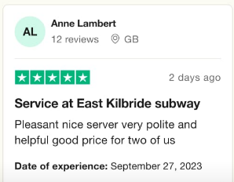

**SALES AND TRANSACTIONS:-**

American company established in 1965 by Fedrik Deluca with support of Peter Buch and alsothe partner of the company.

* Initial Investment - $1000(cr)

1. Worlds largest Single Brand Restaurant Chain
2. Worlds largest Restaurant operator
3. In India it comes in 2001 in New Delhi

* Franchise Fee -6.5 lakhs (INDIA)
* 12.5% Fees on Total Salesis charged per week .Total sales includes 8% royalty and 4.5% advertisement Fee.
* Rs.6-8 lakhs in Interior for matching the standard of subway.
* Equipment cost- 30-50 lakhs.
* Location fees is 2-8 lakhs (In cities 8 lakhs but in tier is 2 lakhs).
* Securities fees =40k to 50k.
* Freight Charges is 45k to55k and Legal charges is 40k to 70k.
* When restaurant is opened then, advertisting charges was 80k to 1.5 lakhs.
* Sign board charges- 75k and Inventory charges is 1.2-1.7 lakh, insurance charges 20-30k.
* Supply charges 20-30k and training charges around 1 lakh
* Miscellaneous charges- 50k to 2 lakhs.
* Additional capital is 3.5 to 5 lakhs.
* Investment to open a subway franchise varies from Rs 5.4 to 8.9 lakhs.

**INVENTORY AND SUPPLY CHAIN**:-

Elements of the Supply Chain

A simple supply chain is made up of several elements that are linked by the movement of products along it. The supply chain starts and ends with the customer.

Customer:- The customer starts the chain of events when they decide to purchase a product that has been offered for sale by a company. The customer contacts the salesdepartment of the company, which enters the sales order for a specific quantity to bedelivered on a specific date. If the product has to be manufactured, the sales order will include a requirement that needs to be fulfilled by the production facility.

Planning:- The requirement triggered by the customer’s sales order will be combinedwith other orders. The planning department will create a production plan to producethe products to fulfill the customer’s orders. To manufacture the products the companywill then have to purchase the raw materials needed.

Purchasing:- The purchasing department receives a list of raw materials and servicesrequired by the production department to complete the customer’s orders. The purchasing department sends purchase orders to selected suppliers to deliver thenecessary raw materials to the manufacturing site on the required date.

Inventory:- The raw materials are received from the suppliers, checked for quality andaccuracy and moved into the warehouse. The supplier will then send an invoice to thecompany for the items they delivered. The raw materials are stored until they arerequired by the production department.

Production:- Based on a production plan, the raw materials are moved inventory to the production area. The finished products ordered by the customer are manufactured

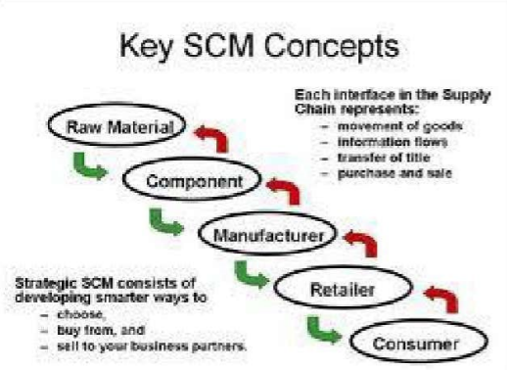

**ENVIRONMENTAL IMPACT**-

The environmental impact on the subway fast food industry refers to how subway restaurants and similar businesses affect the environment. This includes things like the use of resources (like water and energy), waste generation, and greenhouse gas emissions. Subway fast food restaurants can have both positive and negative environmental effects, depending on factors like their energy efficiency, waste management practices, and sourcing of ingredients. Efforts to reduce their environmental footprint might involve using eco-friendly materials, reducing food waste, and adopting sustainable sourcing practices.

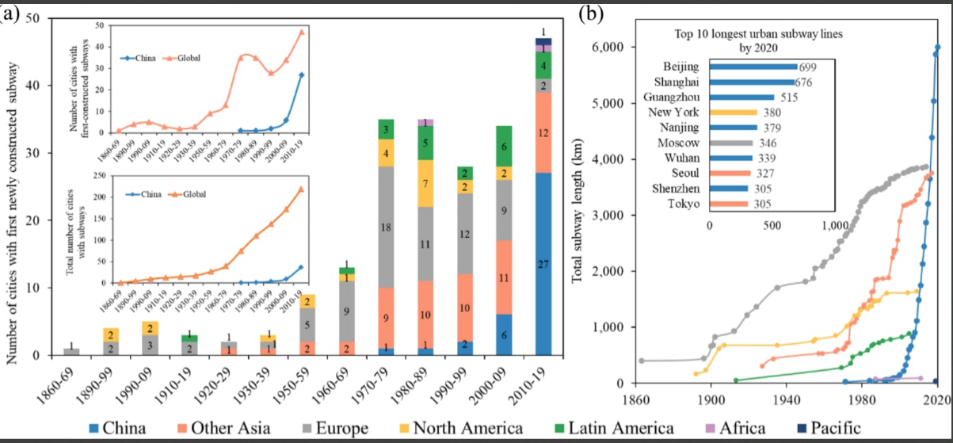

**MARKET RESEARCH:-**

Market research in the subway food industry involves studying customer preferences, competition, and trends. Key areas to explore include:

*Customer Demographics*: Analyze the age, gender, income, and location of your target customers.

Competitive Analysis: Identify rival subway food chains, their offerings, pricing, and market share.

Location Analysis: Assess ideal locations for new outlets based on foot traffic and proximity to competitors.

Menu Trends: Monitor consumer preferences for healthy options, dietary restrictions, and regional tastes.

Pricing Strategy: Determine competitive pricing that aligns with your target market.

Marketing Channels: Explore effective advertising and promotion strategies, including online and social media.

Technology Integration: Investigate digital ordering, delivery apps, and loyalty programs.

Food Safety and Quality: Ensure compliance with industry standards and address customer concerns.

Sustainability: Consider eco-friendly practices to appeal to environmentally conscious consumers.

Growth Opportunities: Identify untapped markets, potential partnerships, or franchise expansion.

Remember to gather data from surveys, interviews, online reviews, and industry reports to make informed decisions.

**STRATEGIES:-**

To resolve these problems, Subway can implement several strategies:

1-**Technology Integration:** Invest in advanced POS systems, mobile ordering apps, and customer relationship management (CRM) tools to enhance the ordering process and collect valuable customer data.

2-**Menu Innovation**: Continuously update and innovate the menu to cater to changing tastes and dietary preferences. Use data analytics to identify popular items and develop new offerings.

3-**Supply Chain Optimization:** Implement data-driven supply chain management systems to minimize disruptions and ensure the availability of fresh ingredients.

4-**Sustainability Initiatives**: Develop and promote sustainable practices, such as reducing packaging waste, sourcing locally, and using renewable energy sources.

5-**Marketing and Branding**: Utilize market research data to tailor marketing campaigns and strengthen Subway's brand identity. Differentiate Subway from competitors through unique selling points.

6-**Employee Training**: Invest in training programs to improve staff performance, customer service, and food preparation consistency.

7**-Continuous Improvement**: Regularly analyze data, gather customer feedback, and adapt strategies to stay responsive to changing market conditions.

By addressing these challenges with data-driven strategies, Subway can enhance its position in the food industry and better meet the evolving needs and expectations of customers.

**VALUES IT WILL BRING TO THE SOCIETY ARE:-**

Integrating technology, innovating the menu, improving supply chain management, focusing on sustainability, enhancing marketing and branding, and investing in employee training within the Subway food industry can bring several societal benefits:

**Convenience:** Technology integration can lead to faster service through online ordering and payment, making it more convenient for customers.

**HealthierOptions**: Menu innovation can include healthier choices, contributing to improved public health.

**Reduced Environmental Impact**: Sustainability initiatives can reduce the environmental footprint of the food industry, such as using eco-friendly packaging and sourcing ingredients responsibly.

**Job Opportunities**: Employee training can provide valuable skills and job opportunities, benefitting local communities.

**Economic Growth**: A more efficient supply chain can stimulate economic growth in the regions where Subway operates.

As for visualization, it's essential to communicate these benefits effectively. Infographics, interactive websites, and social media campaigns can be used to showcase Subway's commitment to these initiatives. Visual representations of reduced waste, healthier menu options, and community engagement can be powerful tools to convey the value brought to society by these efforts.

**USER PERSONA AND USER STORY:-**

Our team will collaborate on various tasks by assigning responsibilities, setting clear goals, and maintaining open communication to ensure efficient and successful outcomes.

**Finance:-Manage by Dixit Surya and Sachin Sharma**

A finance manager in the Subway food industry would handle these strategies as follows:

Technology Integration: Manage budgets for implementing new technology solutions to improve efficiency in operations and customer experience.

Menu Innovation: Analyze the cost implications of introducing new menu items and assess their financial viability.

Supply Chain Optimization: Monitor and control costs within the supply chain, negotiate with suppliers for favorable terms, and assess the financial impact of supply chain decisions.

Sustainability Initiative: Allocate funds for sustainability projects and evaluate their long-term financial benefits, including cost savings and brand reputation enhancement.

Marketing and Branding: Allocate budgets for marketing campaigns, assess the return on investment, and ensure brand consistency while managing costs.

Employee Training: Budget for training programs, evaluate their effectiveness in improving employee performance, and consider cost-efficient training methods.

Continuous Improvement: Allocate resources for process improvement initiatives, measure their impact on cost reduction or revenue enhancement, and prioritize investments accordingly.

**Marketing:-Deepak Kumar and Adarsh Gaur**

A marketing manager in the Subway food industry would handle these strategies as follows:

Technology Integration: Implement digital ordering systems, mobile apps, and data analytics for customer insights.

Innovation: Develop new menu items based on customer preferences and dietary trends, and promote them effectively.

Supply Chain Optimization: Collaborate with suppliers to ensure efficient and sustainable sourcing, reducing costs and environmental impact.

Sustainability Initiatives: Promote Subway's commitment to sustainability through marketing campaigns and eco-friendly packaging.

Marketing and Branding: Create consistent branding messages that emphasize Subway's value, quality, and healthy options.

Employee Training: Highlight Subway's dedication to employee training and customer service in marketing materials.

Continuous Improvement: Showcase Subway's ongoing efforts to enhance the customer experience, food quality, and operations efficiency.

In short, the marketing manager would align marketing strategies with these key areas to promote Subway's brand, values, and offerings effectively.

**HR:- Samriti Chauhan**

HR managers in the Subway food industry can handle these strategies as follows:

Technology Integration: Collaborate with IT to implement digital ordering and payment systems, and ensure employees are trained to use them effectively.

Menu Innovation: Work with culinary teams to identify trends and launch new menu items, and train staff on preparation and presentation.

Supply Chain Optimization: Partner with procurement and logistics teams to streamline supply chains, ensuring timely deliveries and reducing waste.

Sustainability Initiatives: Develop sustainability programs, train employees on eco-friendly practices, and promote green initiatives within the company.

Marketing and Branding: Collaborate with marketing to ensure brand consistency, and train employees on brand values for customer interactions.

Employee Training: Create training programs for onboarding, customer service, and food safety, ensuring all employees are well-prepared.

Continuous Improvement: Establish processes for gathering feedback from employees and customers, and use this data to drive continuous improvement efforts.

In short, HR managers play a pivotal role in aligning human resources with these strategic initiatives, from training and development to fostering a culture of innovation and sustainability.

Operations and supply chain management:-Yuvraj

An operation and supply chain management manager in the Subway food industry can handle these strategies as follows:

Technology Integration: Embrace digital tools for inventory management, ordering systems, and data analytics to streamline operations and enhance customer experience.

Menu Innovation: Collaborate with culinary teams to develop new menu items that align with customer preferences and dietary trends.

Supply Chain Optimization: Implement efficient sourcing, distribution, and inventory control systems to reduce costs and ensure fresh ingredients.

Sustainability Initiatives: Source eco-friendly packaging, implement waste reduction measures, and seek sustainable sourcing options for ingredients.

Marketing and Branding: Coordinate marketing campaigns to promote Subway's unique offerings and values, focusing on health-conscious choices and freshness.

Training: Invest in comprehensive training programs to ensure staff members are knowledgeable about menu items, food safety, and customer service.

Continuous Improvement: Continuously monitor operations, gather customer feedback, and adapt strategies to enhance efficiency, quality, and customer satisfaction.

In summary, the manager should leverage technology, foster innovation, optimize the supply chain, promote sustainability, drive marketing efforts, invest in employee training, and prioritize continuous improvement to succeed in the Subway food industry.

Research and Development:- Ankit